Bangladesh Army International University of Science and Technology
Department of Computer Science and Engineering
Open Ended Lab Report
Lab Report Name | : | Design and Implement a Custom Lexical Analyzer for Source Code.
Course Title | : | Compiler Design & Construction Sessional
Course Code | : | CSE 414
Name | : | Md Khaled Bin Joha
ID | : | 0822220105101052
Level | : | 4 | Term | : 1 | Section | : B | Group | :
Date of Submission | : | 8/1/2026 | Semester | : FALL  25 | Year | : 2026

Key Learnings:
- Lexical Analysis Fundamentals: Learned how source code is broken into meaningful tokens such as keywords, identifiers, operators, and literals—the first stage of a compiler.
- Pattern Matching & Token Classification: Gained experience using character patterns and rules to correctly identify and categorize different token types.
- Practical Compiler Design Insight: Understood how a custom lexical analyzer forms the foundation for further stages like parsing and semantic analysis.

Code Implementation:
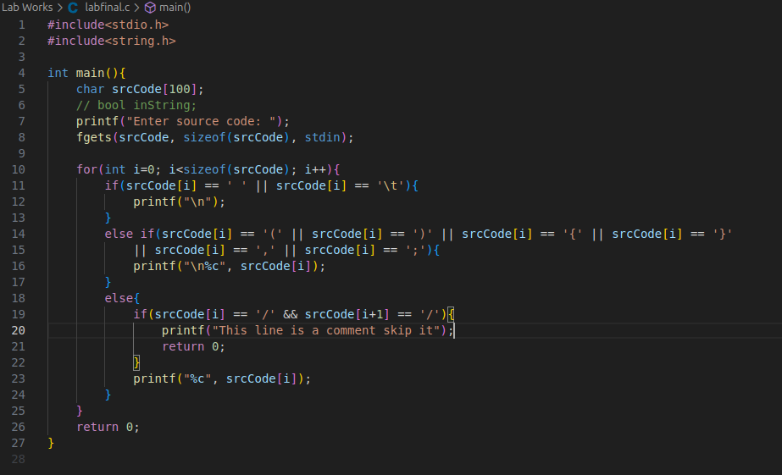

Input Sample:
Enter source code: int a = 5;

Output Sample:
